QUILL & ARROW, LLP
Kevin Y. Jacobson, Esq. (SBN 320532)
kjacobson@quillarrowlaw.com
<< Matter.ResponsibleAttorney.Name >>, Esq. (SBN << Matter.ResponsibleAttorney.JobTitle.Name >>)
<< Matter.ResponsibleAttorney.Email >>
e-service@quillarrowlaw.com
10880 Wilshire Blvd., Suite 1600
Los Angeles, California 90024
Telephone: (310) 933-4271
Facsimile: (310) 889-0645

Attorneys for Plaintiffs,
<< MATTER.CUSTOMFIELD.PLAINTIFFSNAMESHORT >>

superior court of the state of california
county of << Matter.CustomField.County >>
<< Matter.CustomField.PlaintiffsFullLegalName >>,  Plaintiffs,  vs.  << Matter.CustomField.DefendantsFullLegalName >>; and DOES 1 through 10, inclusive,  Defendants. | Case No.: << Matter.CustomField.CaseNumber >>  Assigned for all purposes to the Honorable << Matter.CustomField.Judge >> in Department << Matter.CustomField.CourtDepartment >>  DECLARATION OF KEVIN Y. JACOBSON IN SUPPORT OF PLAINTIFF’S EXPERT WITNESS DESIGNATION  [Filed Concurrently with Plaintiff’s Designation of Expert Witness]  Complaint Filed: << Matter.CustomField.DateMatterFiled >>  Trial Date: << Matter.CustomField.TrialDate.Verbose >>

I, Kevin Y. Jacobson, declare:
- I am an attorney duly licensed to practice law before all courts of the State of California. I am an attorney at the firm of Quill & Arrow LLP. I am one of the attorneys of record for Plaintiffs, << Matter.CustomField.PlaintiffsNameShort >>, as such, I have personal knowledge of the facts contained herein.
- If called as a witness, I could and would be able to competently testify to the facts contained herein.
- This declaration is filed in support of Plaintiff’s Designation of Expert Witnesses.
- Plaintiffs have retained Dr. Barbara Luna. Thomas Lepper, and Darrell W. Blasjo as expert witnesses.
- Dr. Luna, Mr. Lepper, and Mr. Blasjo have agreed to testify as an expert witness at trial.
- A true and correct copy of Dr. Luna’s Curriculum Vitae is attached hereto as

Exhibit 1.
- A true and correct copy of Mr. Lepper’s Curriculum Vitae is attached hereto as

Exhibit 2.
- A true and correct copy of Mr. Blasjo’s Curriculum Vitae is attached hereto as Exhibit 3.
- I am informed and believe and thereon state that Dr. Luna has over thirty years of experience as a forensic accountant and a damages and valuation expert in business, personal injury, and bankruptcy matters. Dr. Luna’s extensive experience includes analyzing financial, accounting, economic, business, and real estate, and valuation issues relating to liability and damages in litigation matters and reorganization of businesses. Dr. Luna has at least thirteen certifications and accreditations, including Certified Fraud Examiner.
- Dr. Luna is expected to testify in Plaintiff’s case in chief as to matters including, but not limited to, corporate customs and practices for public reporting requirements, corporate ethical obligations, board and management duties, relationships, and responsivities, delegation of duties, transmission of information and decision-making within corporate and business structures, fiduciary duties and disclosure obligations, corporate business regulations, including financial regulation, corporate business culture, and responsibilities of executives derived from internal guidelines and documents, industry standards applied to disclosing or omitting material information in the context of external requirements, the materiality of such information, means and techniques of disclosure, corporate philosophy and rick management strategy, her review of internal documents, such as recalls, technical service bulletins, emails, PowerPoint presentations, consumer forms and documents filed in other related legal matters, and her knowledge, training and experience in conducting a fraud investigation as a Certified Fraud Examiner.
- Dr. Luna is also expected to testify as to the valuation of damages based on the financial impact of omissions, the quantification of culpability of the defendant, the quantification of the reprehensibility of << Matter.CustomField.DefendantsAbbreviatedName >>’s conduct including, but not limited to, the repeated wrongdoing, and profitability of the scheme.
- I am informed and believe and thereon state that Mr. Lepper is an expert in the field of automotive consulting, inspection, and evaluation in the automotive industry for more than thirty years. Mr. Lepper has more than fifteen years of experience as a forensic automotive investigator.
- I am informed and believe and thereon state that Mr. Blasjo is an expert in the field of automotive consulting, inspection, and evaluation in the automotive industry for more than twenty years. Mr. Blasjo has more than twenty years of experience as a forensic automotive investigator.
- Mr. Lepper and Mr. Blasjo will testify regarding matters including but not limited to, the subject vehicle and its warranty and repair history, testing procedures, interpretations of results and further diagnostic repair procedures, both generally and as regards the subject vehicle, reasonableness of the repair attempts regarding the subject vehicle, and warranty repair procedures. Also compare the observations to << MATTER.CUSTOMFIELD.DEFENDANTSNAMESHORT >>’s documents, including but not limited to: TSBs, SSMs, recalls, emails, PowerPoint Presentations, consumer forms and documents filed in other legal matters.
- Dr. Luna, Mr. Lepper, and Mr. Blasjo will be sufficiently familiar with the facts of this case to submit to a meaningful oral deposition including their expert opinion and the basis of their opinion.
- Dr. Luna, Mr. Lepper, and Mr. Blasjo have agreed to testify at the trial of this matter, which is presently set for << Matter.CustomField.TrialDate.Verbose >>.

I declare under penalty of perjury under the laws of the State of California that the foregoing is true and correct.

Dated: << Date.Verbose >>

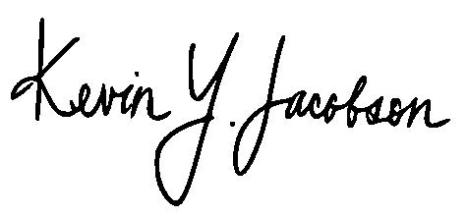
QUILL & ARROW, LLP

________________________
Kevin Y. Jacobson, Esq.
Attorney for Plaintiffs,
<< MATTER.CUSTOMFIELD.PLAINTIFFSNAMESHORT >>

EXHIBIT 1

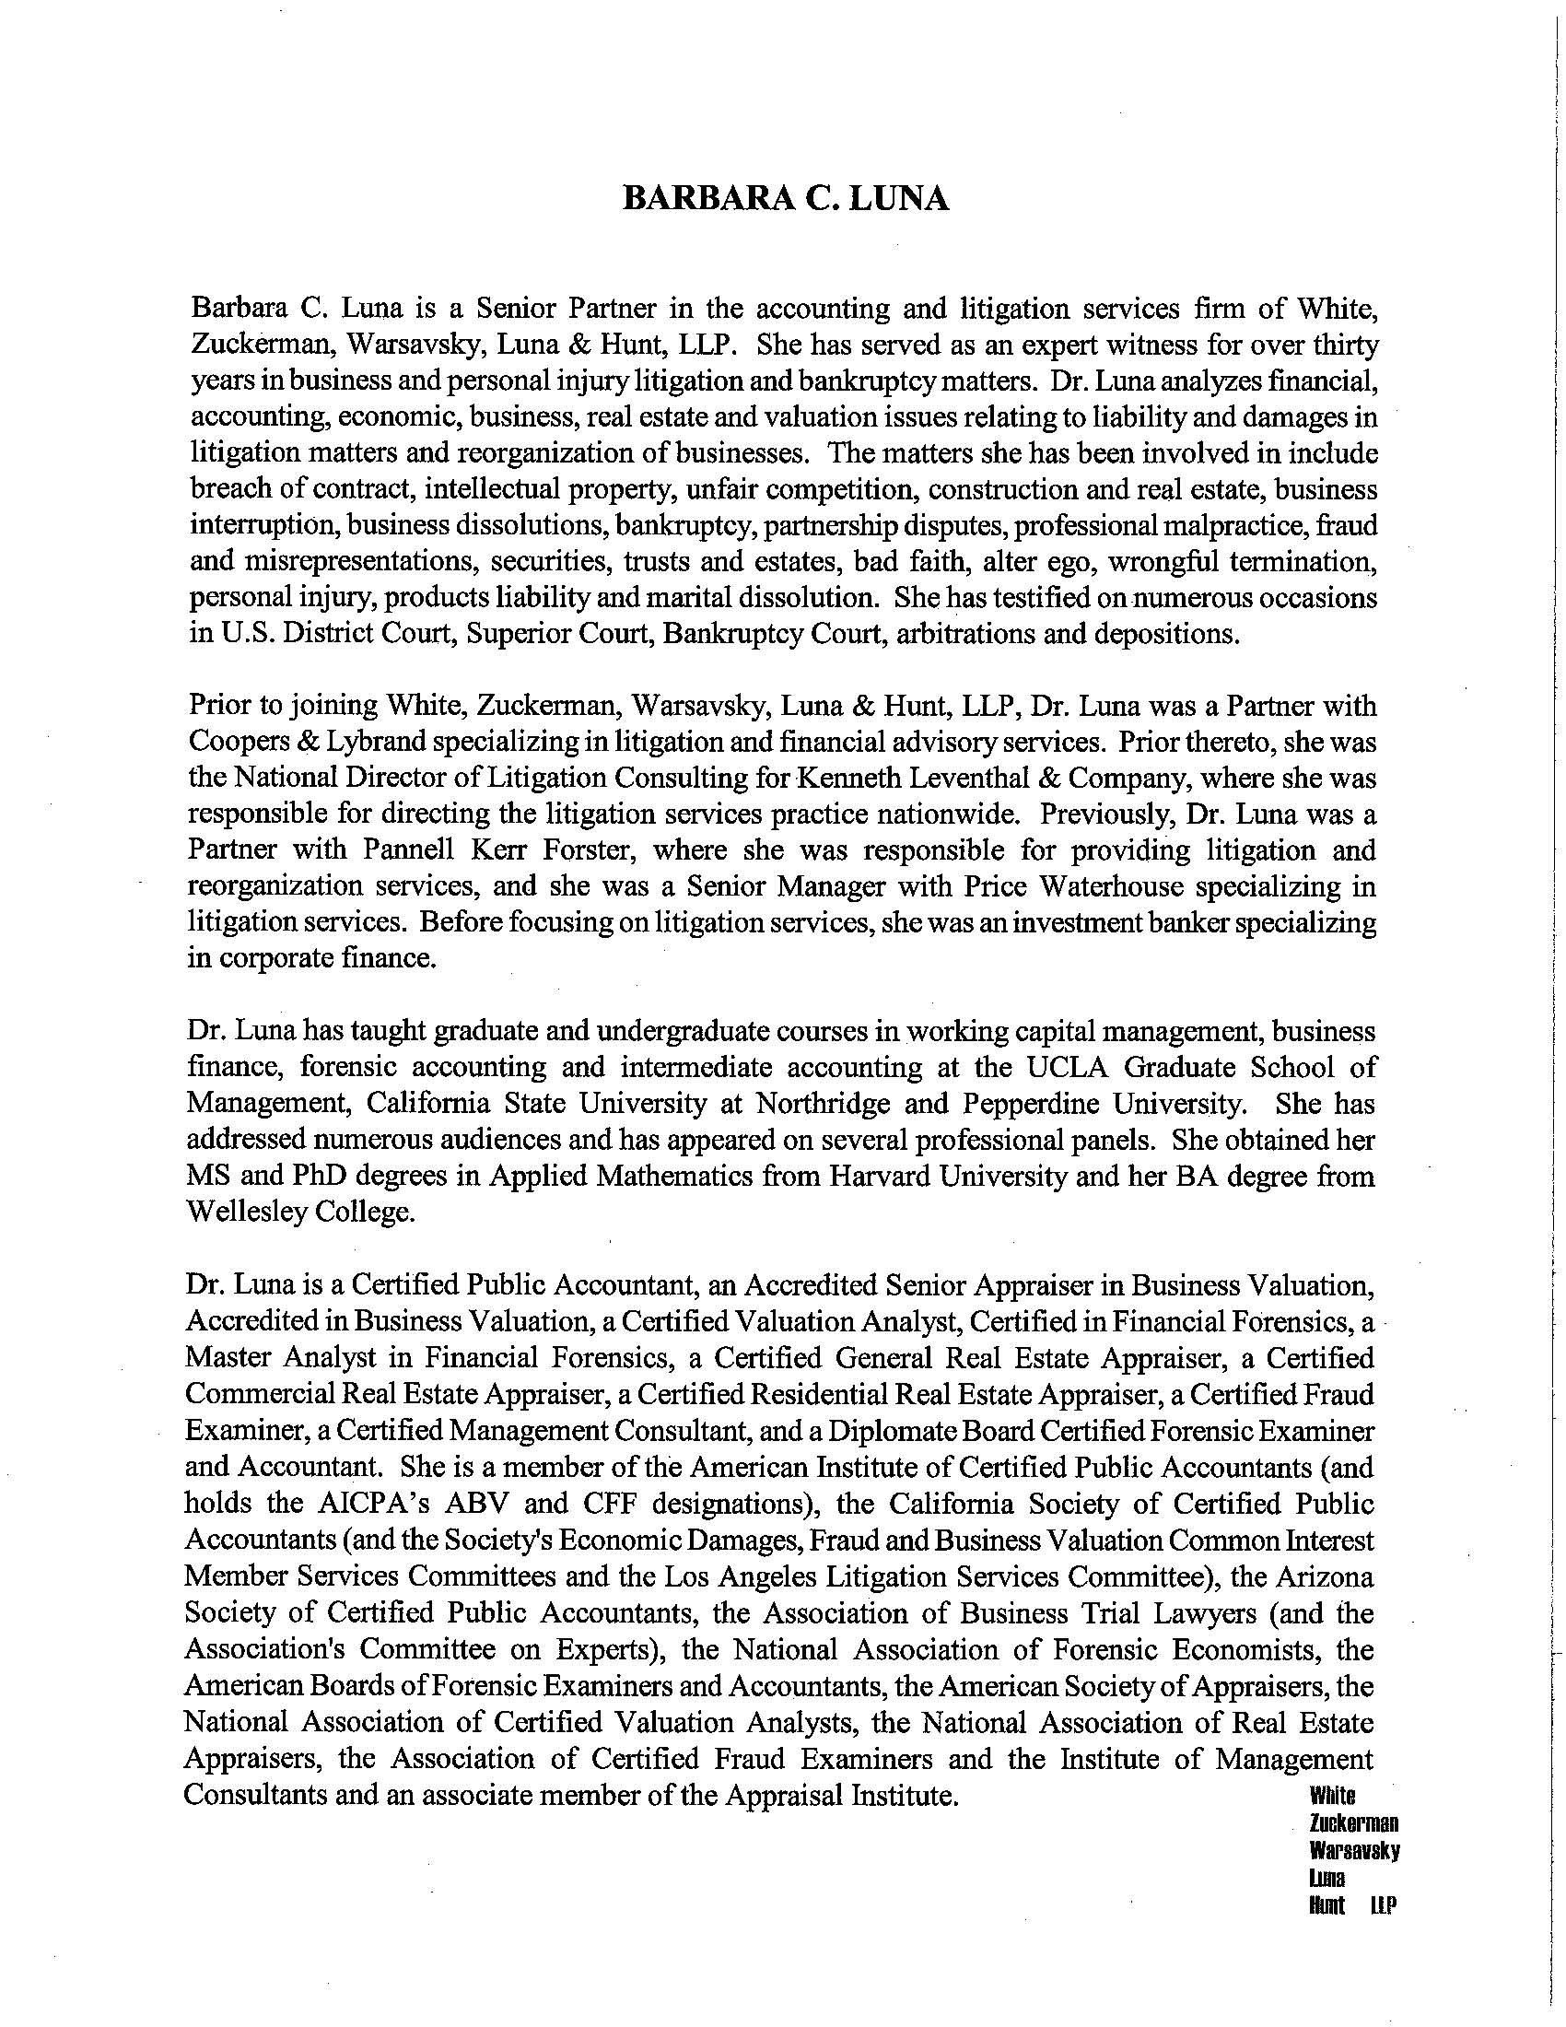

EXHIBIT 2

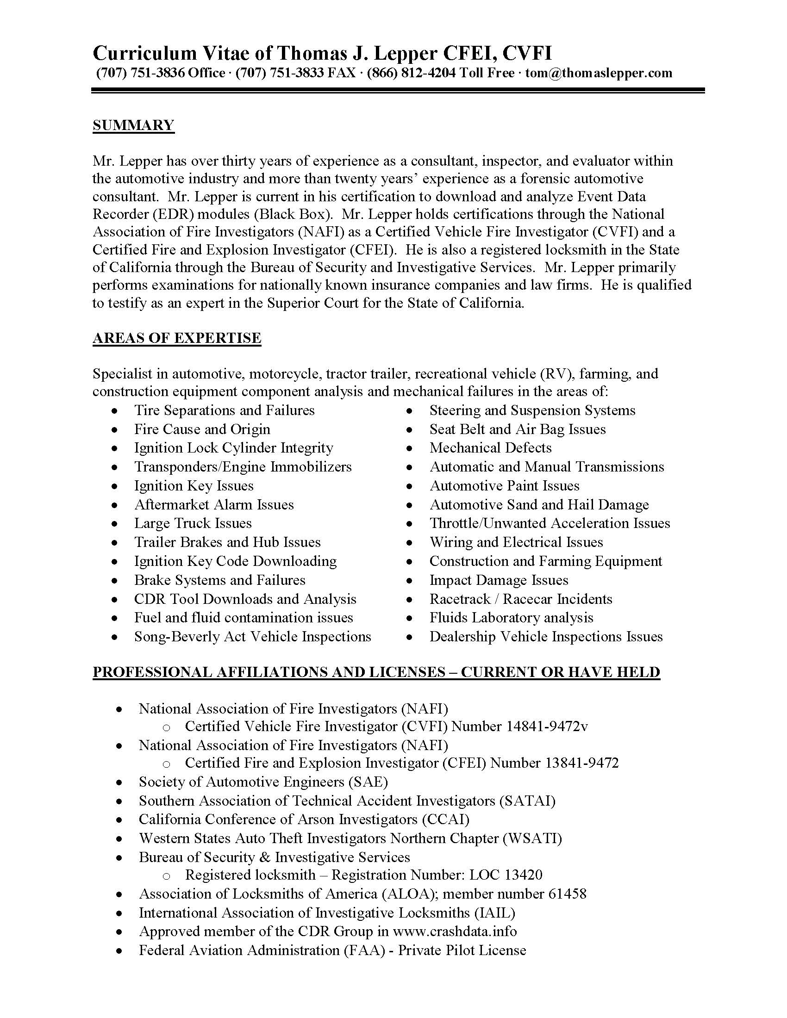

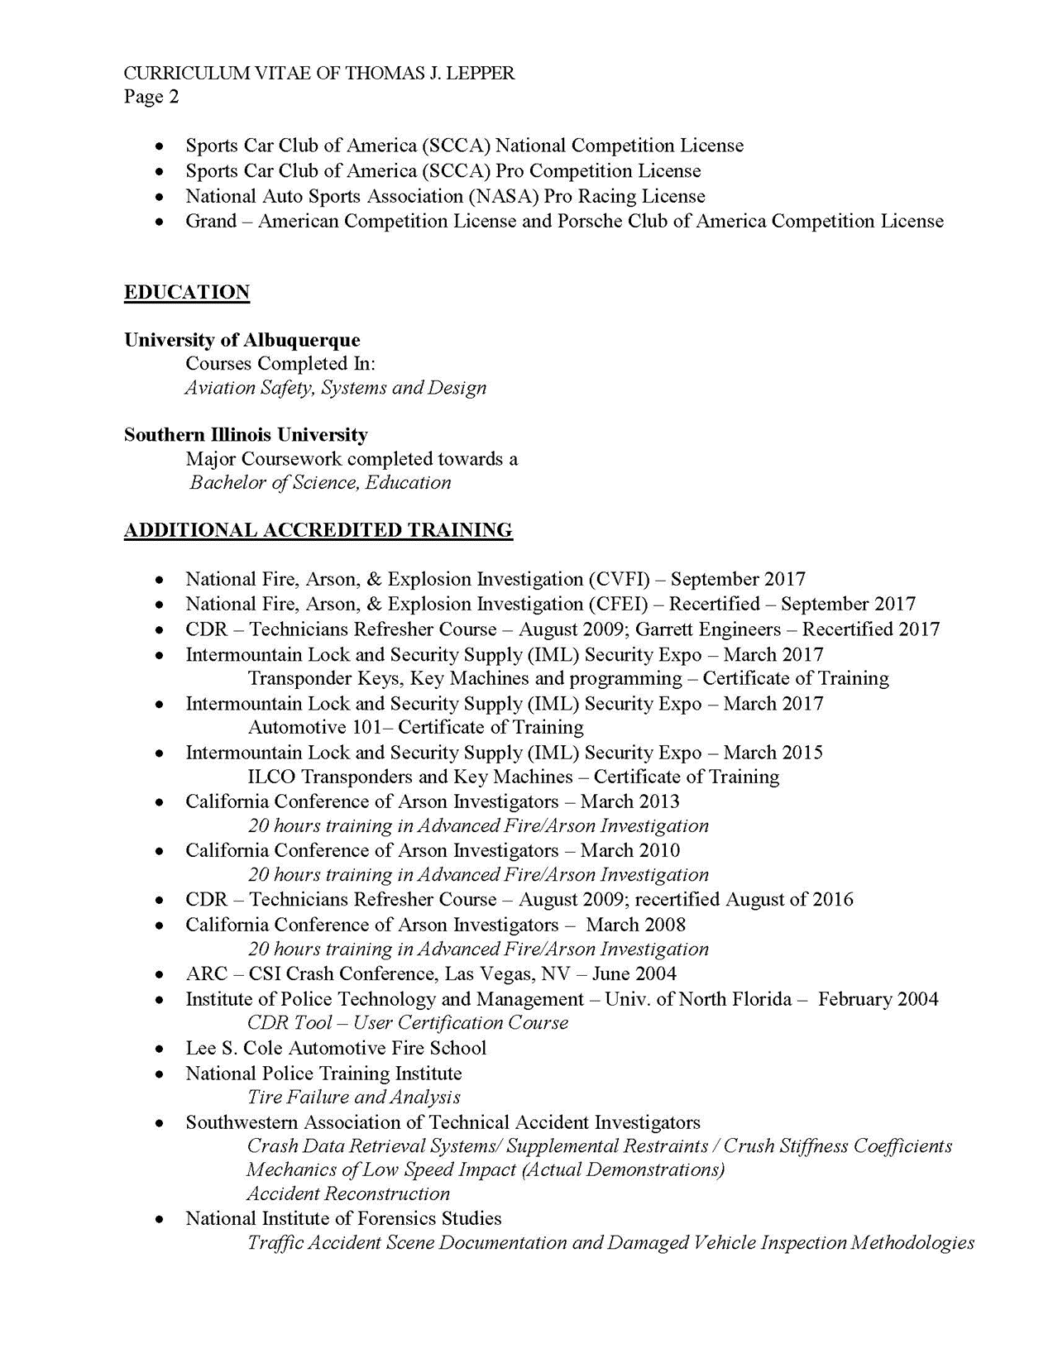

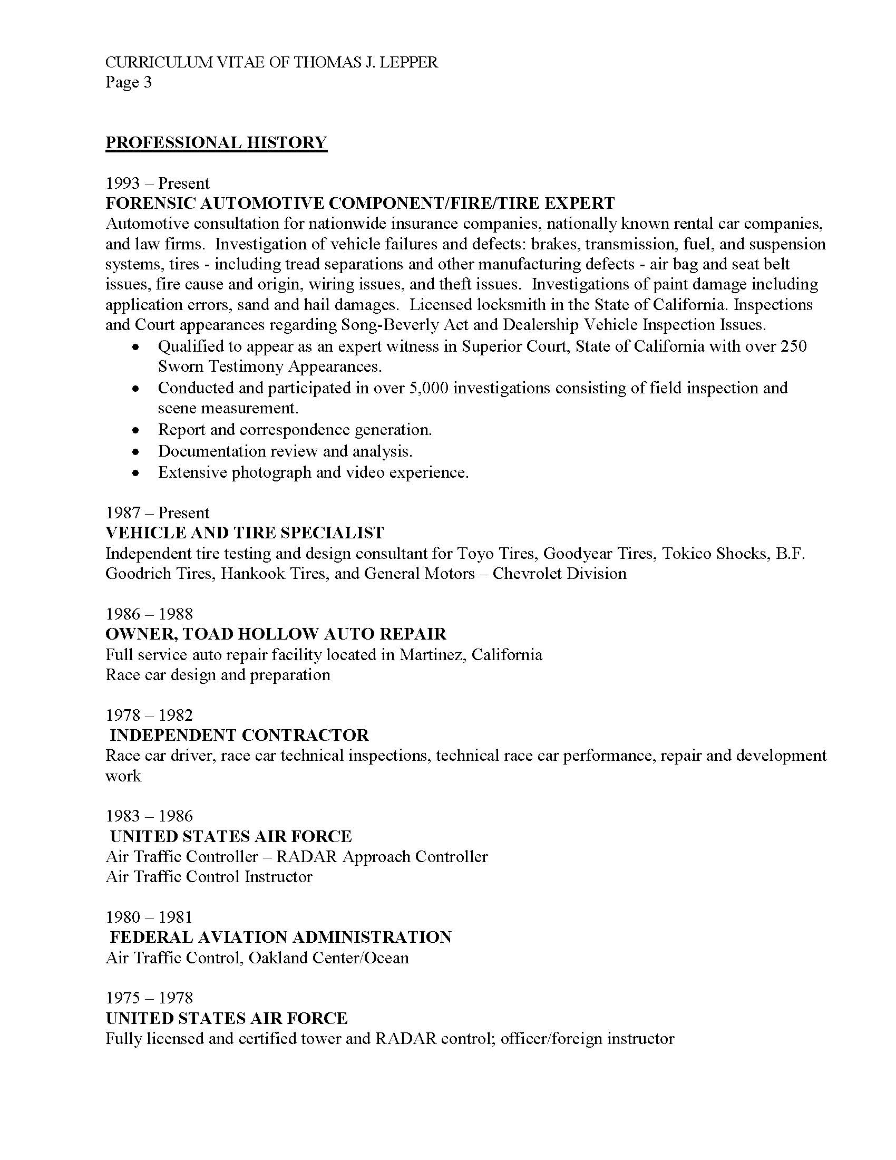

EXHIBIT 3

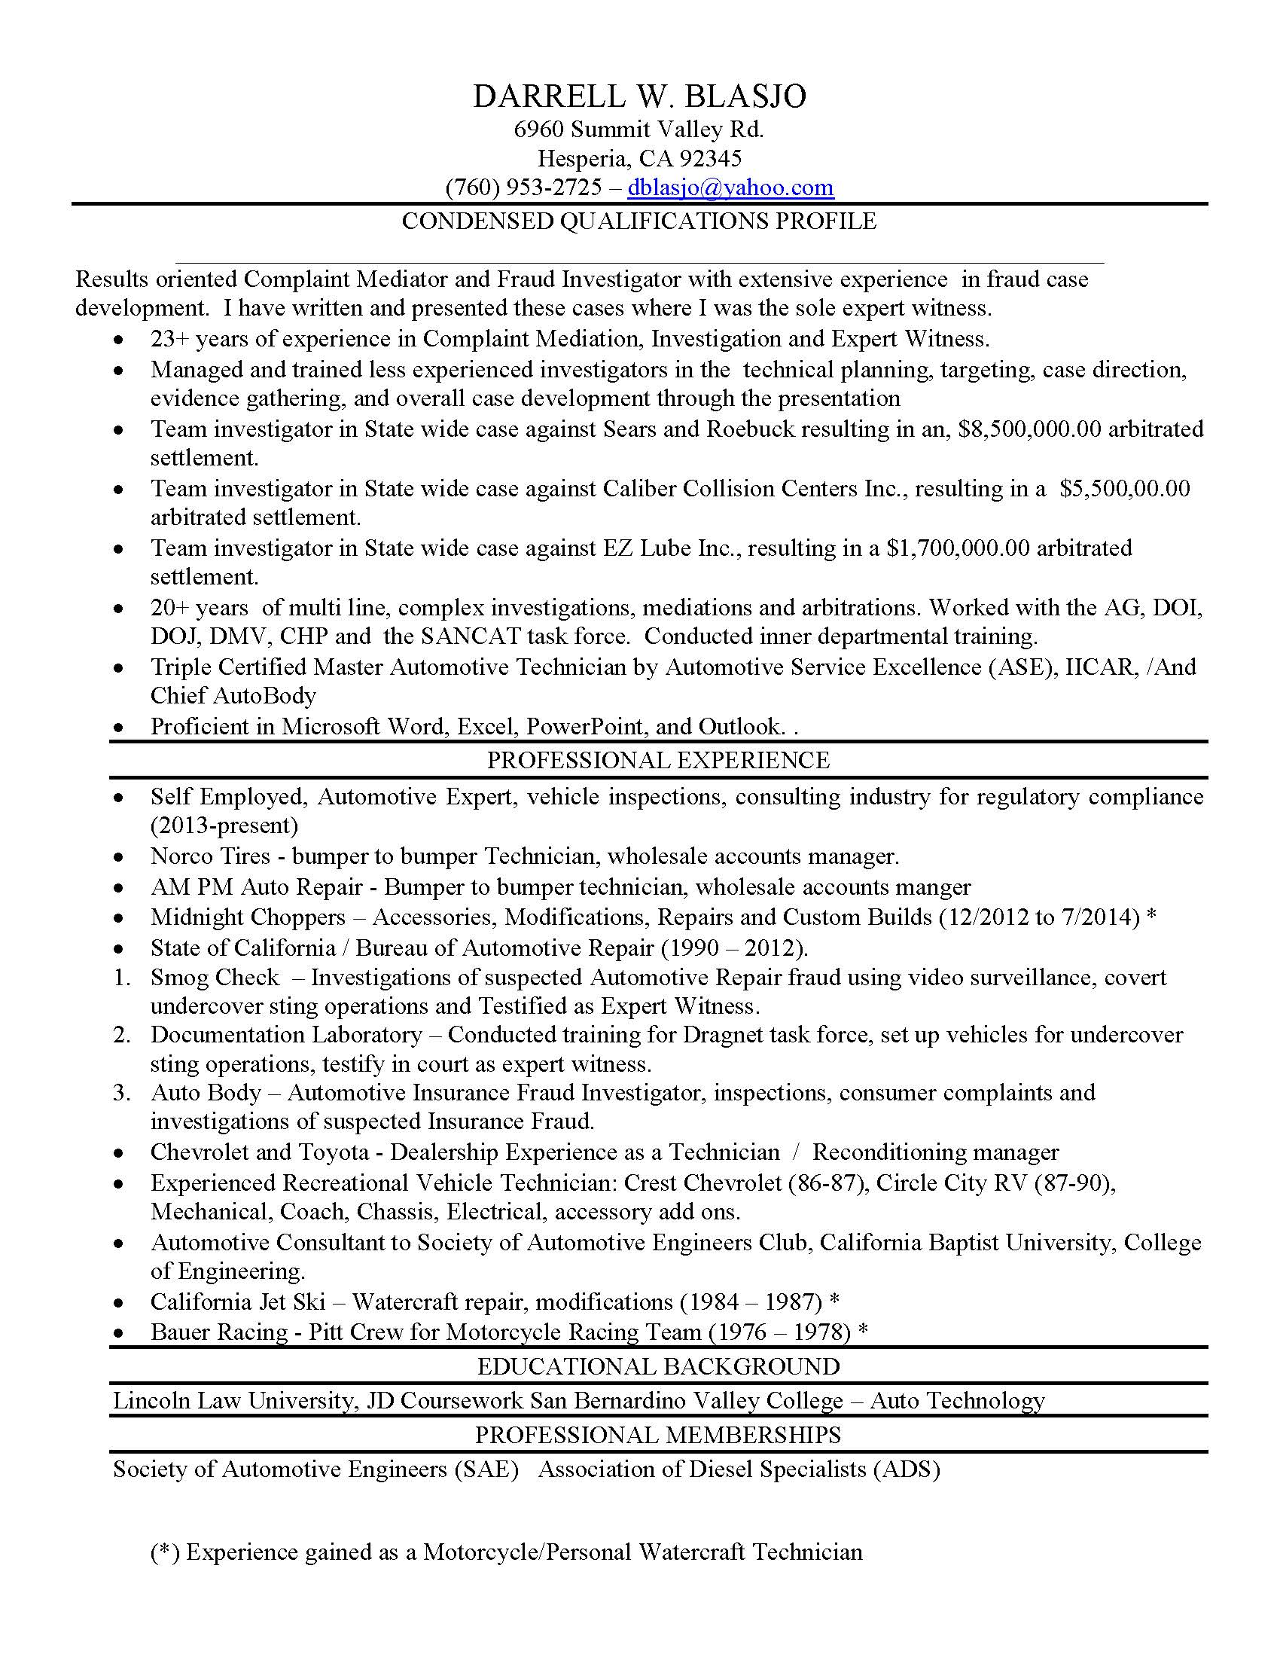

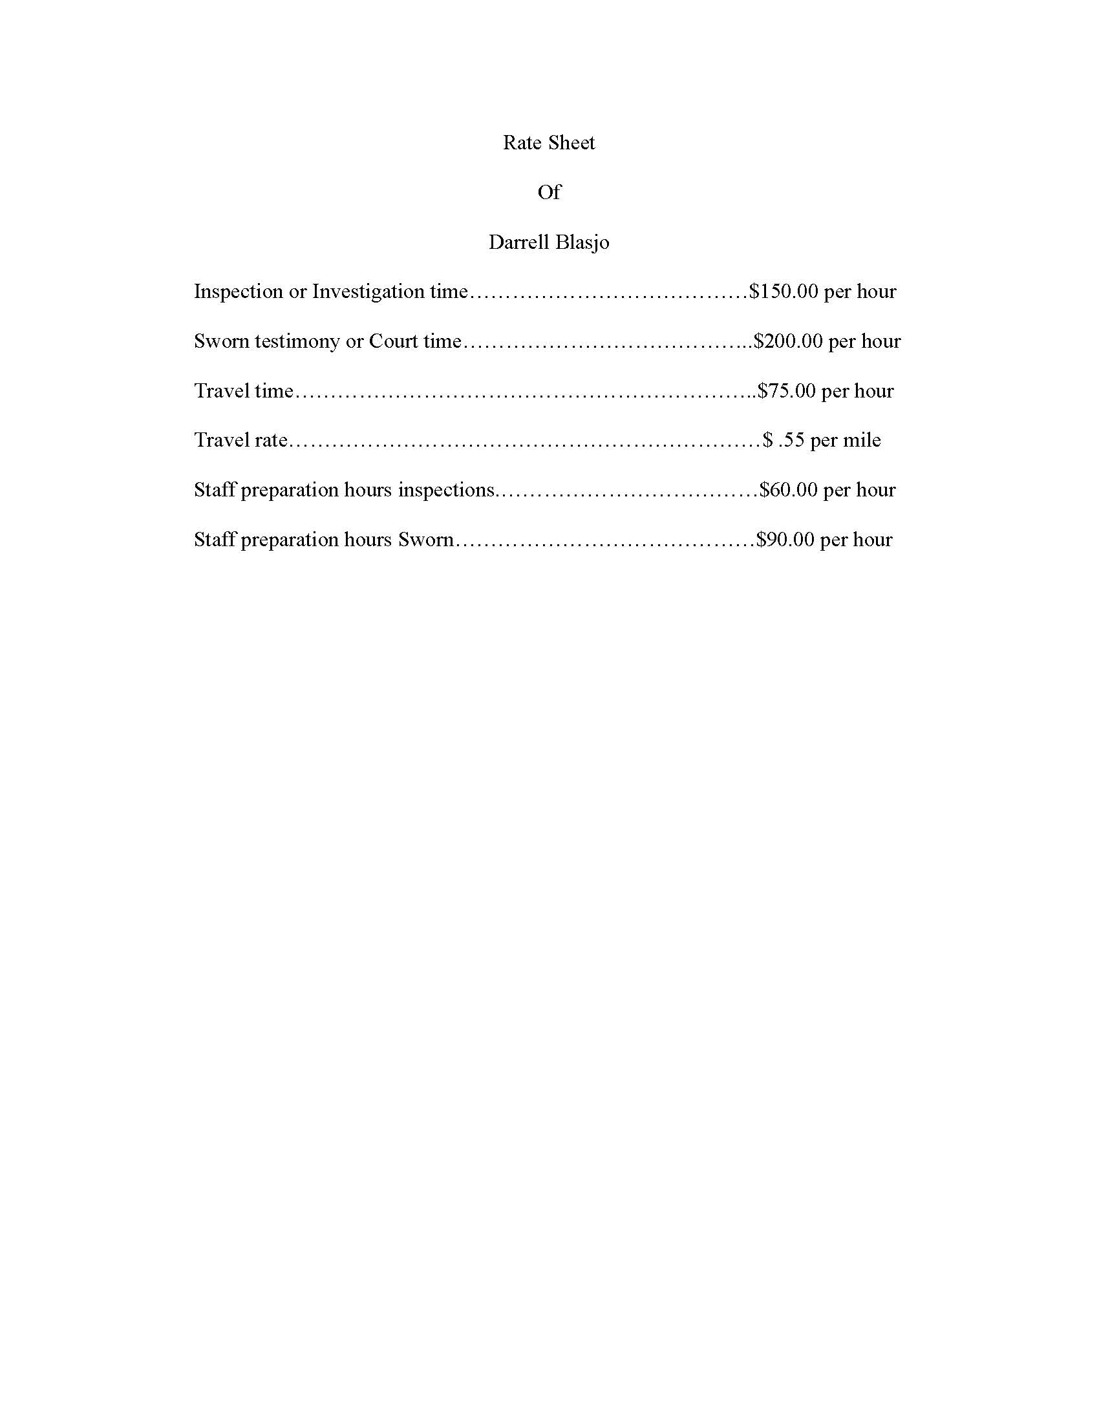

PROOF OF SERVICE

I am employed in the County of Los Angeles, State of California. I am over the age of 18 and not a party to the within action. My business address is 10880 Wilshire Blvd., Suite 1600, Los Angeles, California 90024.

On << Date.Verbose >>, I served the following document(s) described as:

DECLARATION OF KEVIN Y. JACOBSON IN SUPPORT OF PLAINTIFF’S EXPERT WITNESS DESIGNATION

That document was served on parties herein in this proceeding by placing true copies of the original in enclosed, sealed envelope(s) addressed as follows:

SEE ATTACHED SERVICE LIST

[] (BY MAIL) I am “readily familiar” with the practices of Quill & Arrow, LLP, in collecting and processing correspondence and documents for mailing. Under that practice, documents for mailing would be deposited with the US Postal Service on that same day this affidavit is signed with postage fully prepaid at Los Angeles, California in the ordinary course of business. I am aware that on motion of the party served, service is presumed invalid if the postal cancellation date is more than 1-day after the day of deposit for mailing the affidavit. [CCP § 1013]

[] (BY OVERNIGHT MAIL) I am “readily familiar” with the practices of the Quill & Arrow, LLP, for collection and processing of documents for mailing via overnight delivery. I caused such document(s) to be placed in a sealed envelope designated by the overnight service carrier, addressed to the person(s) on whom it is to be served pursuant to the attached service list, and deposited said envelope in a box or other facility regularly maintained by the overnight service carrier with delivery fees paid or provided for. [CCP § 1013(c)]

[X] (BY ELECTRONIC MAIL) I caused the document(s) to be transmitted by electronic mail to the e-mail addresses for each party indicated on the attached service list.

[] (BY PERSONAL DELIVERY) I caused to be delivered such envelope by hand to the addressee at the address indicated on the attached service list.

I declare under penalty of perjury under the laws of the State of California that the foregoing is true and correct.

Executed on << Date.Verbose >>.
/s/ << User.Name >>

<< User.Name >>

SERVICE LIST

<< Matter.CustomField.OcName1 >>  << Matter.CustomField.OcName2 >>  << Matter.CustomField.OcName3 >>  << Matter.CustomField.OcFirmName >>  << Matter.CustomField.OcStreetAddress >>  << Matter.CustomField.OcCityStateZip >> | Counsel for Defendants

